Hotel Booking System



We have four logins:

1. Hr Login
2. Executive Login
3. Customer Login
4. Hotel Admin login

@PostMapping("/hr/add"):Adding Hr

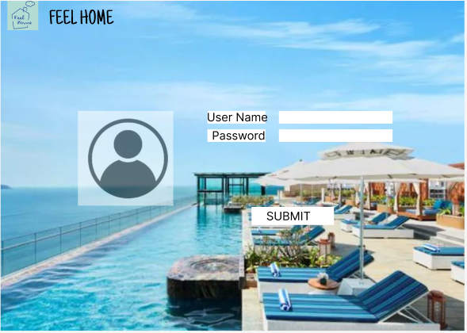



@PostMapping("/executive/add"):Adding Executive

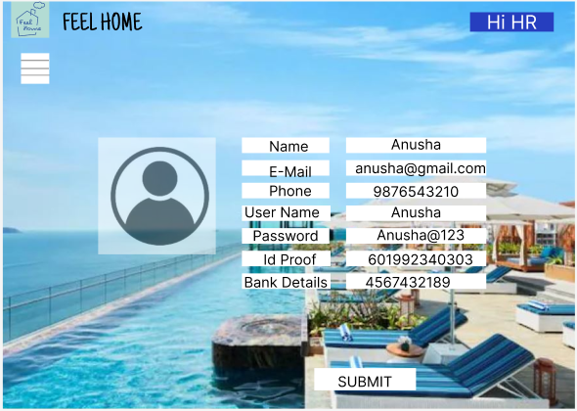

Hr can get all Executive details

@GetMapping("/hotel/getallexecutives")

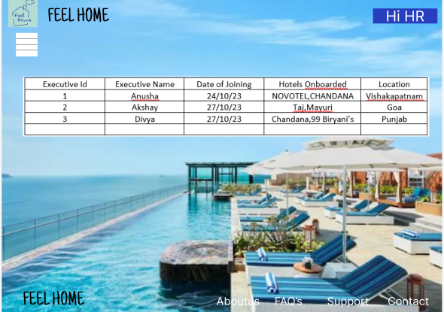

@GetMapping("/getone/{eid}")

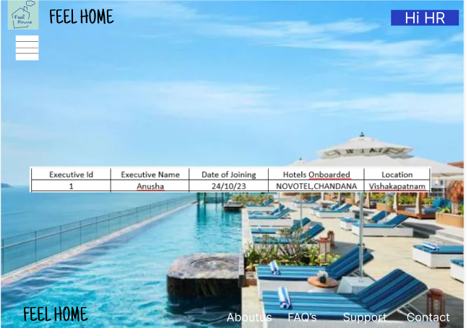

Updating Executive details

@PutMapping("/executive/updateExecutive/{eid}")



To Delete Executive

@DeleteMapping("/executive/delete/{id}")

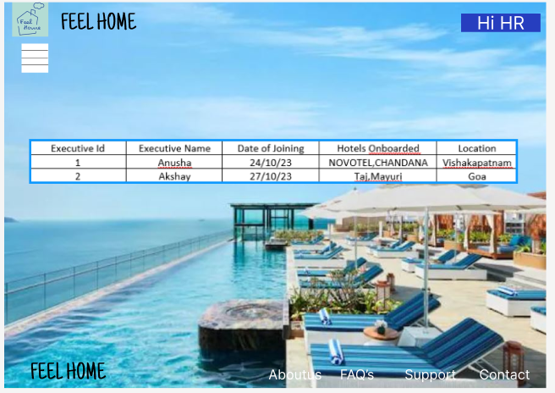

Adding HotelAdmin

@PostMapping("/hoteladmin/add/{eid}")





@GetMapping("/hoteladmin/getall")

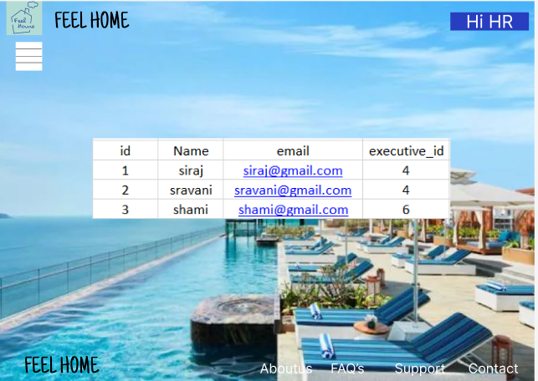

@GetMapping("/hoteladmin/getbyexecutive/{eid}")

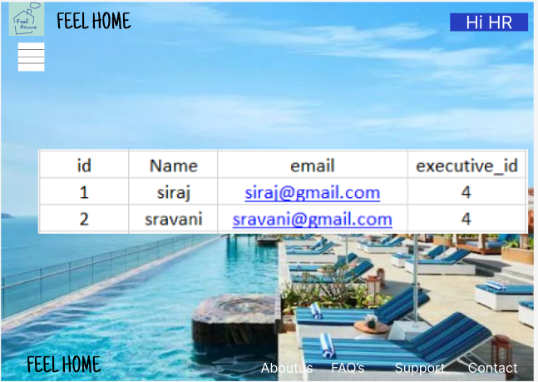

@PutMapping("/hoteladmin/updatehoteladmin/{aid}")



@DeleteMapping("/hoteladmin/deletehoteladmin/{aid}")



Adding Location:

@PostMapping("/location/add/{eid}")

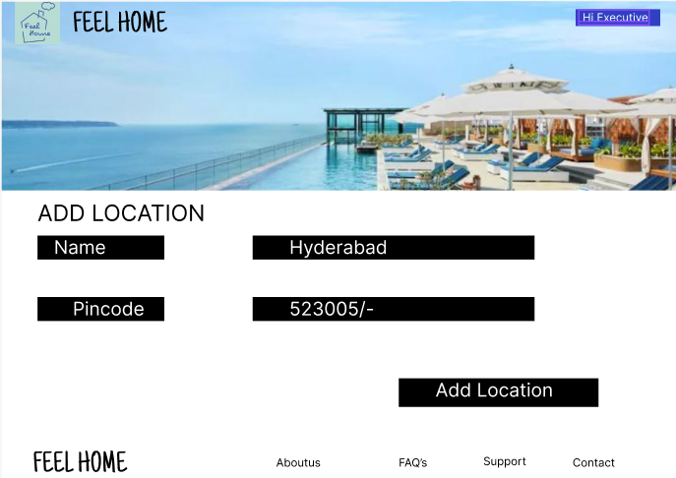

@DeleteMapping("/location/deletelocation/{lid}")

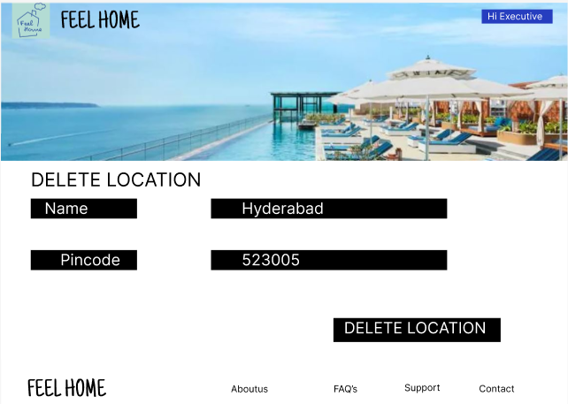

Adding hotel by admin_id and location_id

@PostMapping("/hotel/add/{aid}/{lid}")

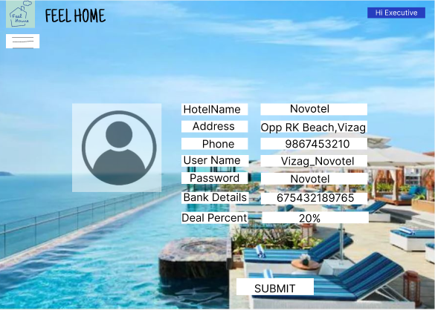

To get all hotels:

@GetMapping("/getallhotels")

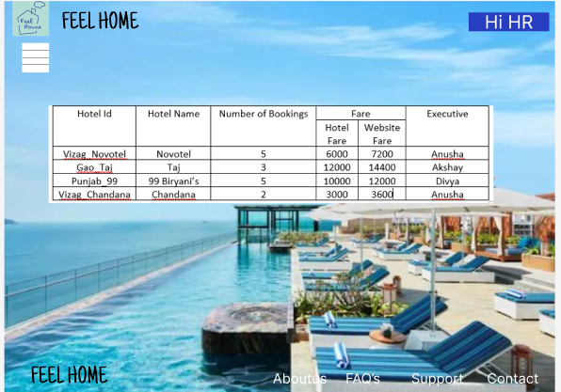

Get all hotels by executive id:

@GetMapping("/hotel/getAllByExecutive/{eid}")



Get hotels by location_id:

@GetMapping("/hotel/getAllByLocation/{lid}")

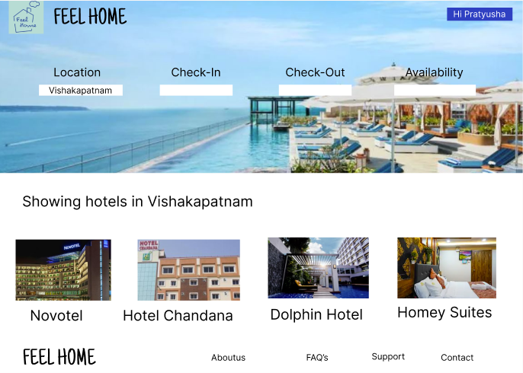

Get hotels by id:

@GetMapping("/hotel/getByHotel/{hid}")

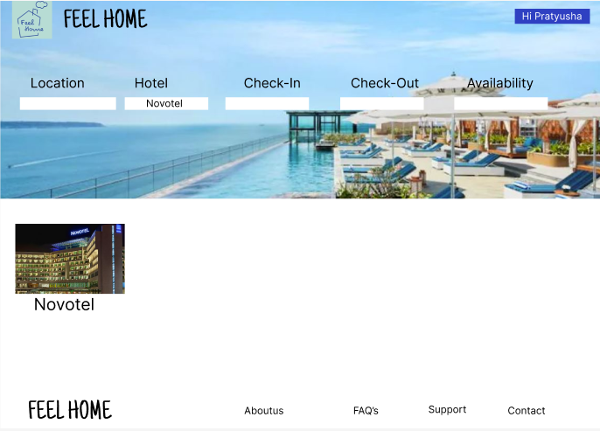

Deleting hotel:

@DeleteMapping("/hotel/delete/{id}")

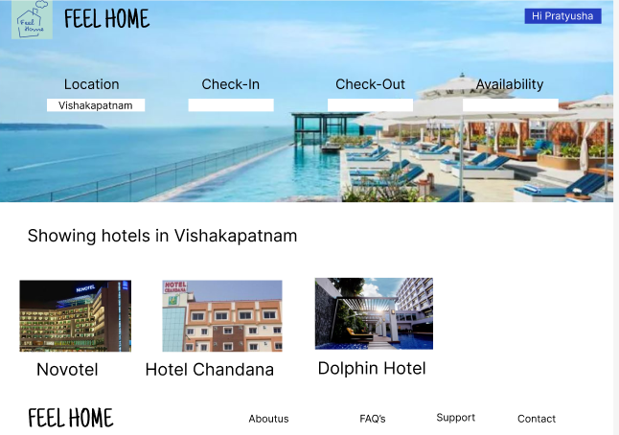

Update hotels:

@PutMapping("/hotel/updatehotel/{hid}")

Adding Customer:

@PostMapping("/customer/add")

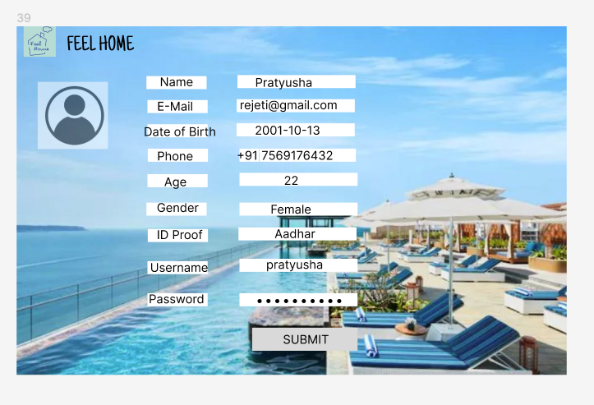

Get Customer by id:

@GetMapping("/customer/getone/{cid}")

Adding Customer Family details:

@PostMapping("/family/add/{cid}")

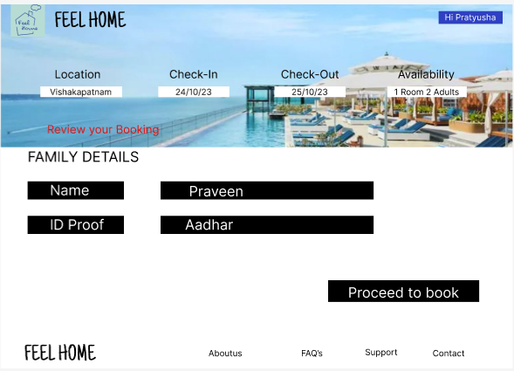

Adding booking details:

@PostMapping("/booking/add/{cid}")

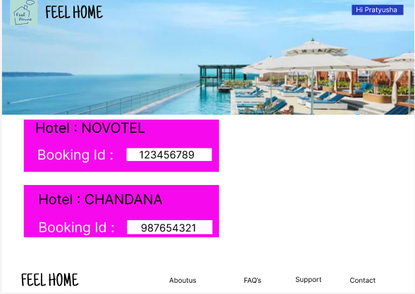

Deleting booking:

@DeleteMapping("booking/cancel/{bid}")

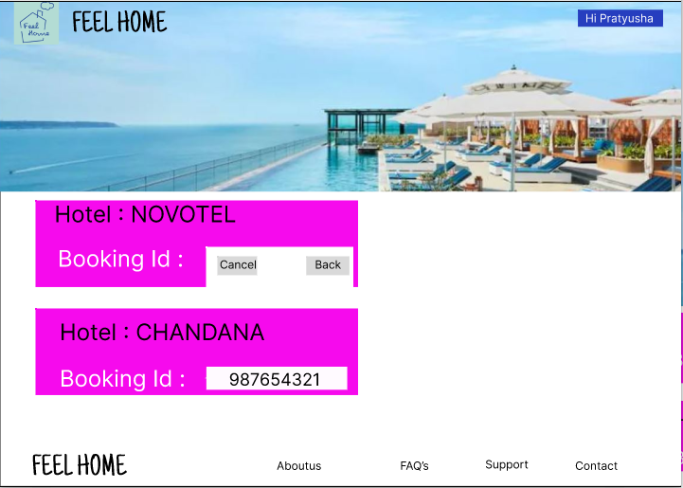

Getting users:

@GetMapping("/user/login")





